

My Target: ____ / 52 or ______ % Complete on the day of the test

🖒 🖓 (Circle when your assignment is handed back)

|  |  |  |
| --- | --- | --- |
| Total marks **52** | **%** | **Weight**  **7.5 %** |
|  |  |  |

**Name: ________________________________**

**Teacher: _________________________________**

Year 9 Humanities & Social Sciences: *Civics & Citizenship*

***Assessment 8 –* In-Class Multiple Choice and Short Answer Responses**

**Instructions: Complete all questions. Working time 45 minutes; 5 minutes reading time.**

Section One – Multiple Choice

1. What does the term “civil law” refer to?
2. Laws relating to private relations between members of a community.
3. Laws relating to behaviour that is prohibited by the government.
4. Laws relating to relationships between countries or states.
5. Laws relating to relationships between the government and its citizens.
6. What does the term “criminal law” refer to?
7. Laws relating to private relations between members of a community.
8. Laws relating to behaviour that is prohibited by the government.
9. Laws relating to relationships between countries or states.
10. Laws relating to relationships between the government and its citizens.
11. In Western Australia, if you are under 18 and accused of a crime you will have to attend:
12. The Children’s Court.
13. The Supreme Court of Western Australia.
14. The District Court of Western Australia.
15. The Magistrates Court of Western Australia.
16. Which of the following correctly describes the hierarchy of Western Australia’s courts, from the **lowest** to **highest** court?
17. Supreme Court of Western Australia, District Court of Western Australia, Magistrates Court of Western Australia.
18. District Court of Western Australia, Magistrates Court of Western Australia, Supreme Court of Western Australia
19. Magistrates Court of Western Australia, Supreme Court of Western Australia, District Court of Western Australia.
20. Magistrates Court of Western Australia, District Court of Western Australia, Supreme Court of Western Australia.
21. Which Western Australian court can hear criminal cases for which the maximum penalty is life imprisonment?
22. Magistrates Court of Western Australia.
23. Coroners Court.
24. Supreme Court of Western Australia.
25. District Court of Western Australia.
26. Which of the following is **NOT** a feature of the Australian legal system?
27. All persons are considered innocent until proven guilty.
28. The power of the government is divided between the judiciary, executive and legislature.
29. All persons are equal before the law.
30. The decisions of all the courts are final and cannot be challenged.
31. In a criminal case the right to a fair trial, means that the trial must be fair to who?
32. The defendant
33. The victim
34. Witnesses
35. All of the above.
36. How many people serve on a jury?
37. 21
38. 12
39. 10
40. 13
41. A person who brings a case against another in court in known as
42. Defendant
43. Plaintiff
44. Defence
45. Offence
46. Laws are made:
47. To protect the society
48. To protect individuals
49. Both (a) and (b)
50. To protect the government
51. The last step in making a law in Parliament is:

a. When the bill is presented to Parliament

b. When it passes its third reading

c. When it is published in the Government Gazette

d. When the Governor or Governor General signs it

1. A person who continually has noisy parties can be sued by one of their neighbours under the section in the law of Torts known as:
2. Negligence
3. Defamation
4. Nuisance
5. Public Order
6. A jury’s job is to:
7. Judge guilt or innocence only
8. Judge guilt or innocence and set the punishment
9. Ask questions of the witnesses
10. All of the above
11. The best term to describe the present political system in Australia is:

a. Constitutional Monarchy

b. Dictatorship

c. Democratic Republic

d. Direct Democracy

**15**. A government minister’s area of responsibility is called their:

a. Cabinet

b. Department

c. Session

d. Portfolio

**16.** The name given to the leader of the majority party in the Lower House of the Federal Parliament is the:

a. Speaker

b. Premier

c. Prime Minister

d. Leader of the Opposition

**17.** The Australian Constitution can only be changed by:

a. Election

b. Law

c. Referendum

d. Amendment

**18.** A book which contains all the names of those people who are able to vote in an election is called a/ an:

a. Electoral roll

1. Membership record
2. Gazette
3. Ballot paper
4. A person who stands for parliament but does not belong to any particular   
   party is a/an:
   1. Member
   2. Independent
   3. Non-partisan
   4. Elector
5. A law is a rule made by the government or courts which:

a. Applies to all people in the world

b. Applies to all people in the society

c. Applies to all people except the government

d. All the above

**21**. Nowadays, laws in Australia are made by:

a. State and Federal Courts

b. State and federal Parliament

c. Local councils

d. All of the above

**22.** Which of the following is not a function of government?

a. Legislative

b. Judicial

c. Consultative

d. Executive

**23.** Within the Australian Government, carrying out the law is called the:

a. Executive task

b. Police task

c. Legislative task

d. Judicial task

**24.** A combination of two or more parties to form an executive or government is:

a. Joint – exercise

b. Coalition

c. Combination

d. Distribution

**Section Two: Short Answer**

* + - 1. In the following decide whether the laws being broken are **civil or criminal.** **(5 marks)**

1. You arrive home and you house has been broken into _______________________
2. Your brother or sister falls over on a slippery floor at a supermarket and there was not sign to inform you of this ___________________________
3. The plaintiff charges that her neighbour built a fence on her property and she wants it removed but the neighbour will not comply. ________________________
4. You have spread rumours on Facebook ___________________________
5. There was a fight in a local park and someone was stabbed ___________________________

**2.** Refer to Source A to complete the question below.

Identify the people in the court A to D **(4 marks)**

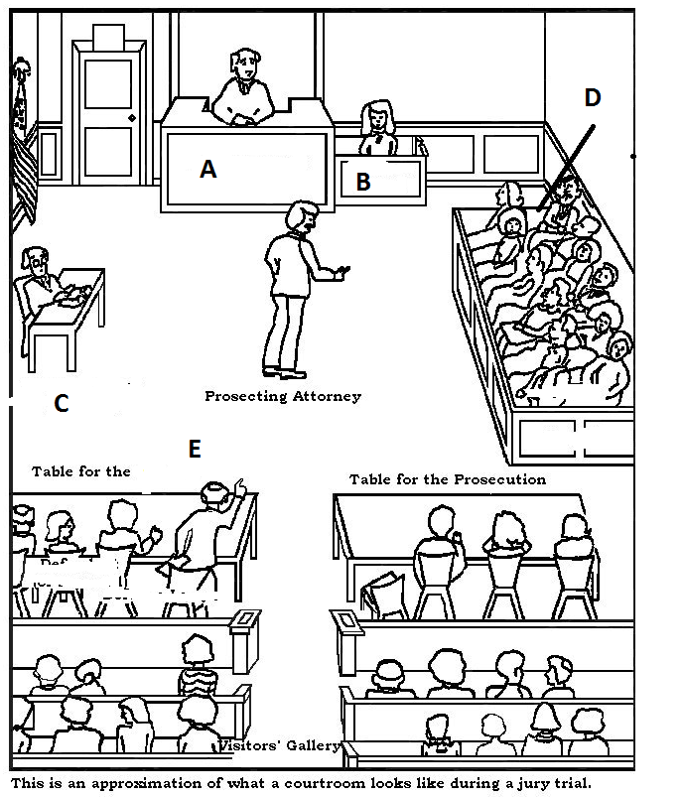

**A______________________________**

**B______________________________**

**C______________________________**

**D______________________________**

1. **Refer to Source B and complete the questions that follow.**

**Source B*:*** *Settlement reached in birth negligence case*, Sarah Farnsworth, 23rd August 2010, http://www.abc.net.au/news/

**Settlement reached in birth negligence case**

A private hospital and a doctor have reached an in-principle agreement to pay compensation to a 12-year-old Victorian boy born with cerebral palsy. David Hanssen took legal action against obstetrician Dr Brett Marshall and the Peninsula Private Hospital in Frankston. He was seeking millions of dollars in compensation and damages after being born with severe intellectual and physical disabilities.

It was alleged the midwives and doctor were negligent in administering too much of a drug used to induce labour during the boy's delivery. The jury in the case was dismissed after the court heard a settlement had been reached. David's mother, Kathryn Hanssen, says the outcome will help her son have a better quality of life.

"It's given us a real sense of relief that we now know that David's going to be really, really happy and really good for the rest of his life."

* 1. Is the case described in Source B civil or criminal? **(1 mark)**

______________________________________________

* 1. Based on your understanding of the types of cases heard in each court, state the name of the State Court this case be heard in.

Name of Court: ____________________________________________ **(1 mark)**

Outline why the case would be heard in that court. **(2 marks)**

________________________________________________________________________________________________________________________________________________________________________________________________________________________________________________________________________________________________________________________

* 1. Outline a reason why might the parties have chosen to settle the case outside of court? **(2 marks)**

________________________________________________________________________________________________________________________________________________________________________________________________________________________________________________________________________________________________________________________

* + 1. Complete the following about 2 Political Parties in Australia: State the name, its current leader, whether is it is a major/minor party and outline a key policy that they are advocating for. **(10 marks)**

**Party One**

* + - * 1. State name of the Party: _______________________________________________ **(1)**
        2. State the name of the current Leader of the Party: ___________________________ **(1)**
        3. State if it is a Major or Minor Political Party: ________________________________ **(1)**
        4. Outline a key value/belief of the party: **(2)**

______________________________________________________________________________________________________________________________________________________

**Party Two**

1. State name of the Party: ______________________________________________ **(1)**
2. State the name of the current Leader of the Party: ___________________________ **(1)**
3. State if it is a Major or Minor Political Party: ________________________________ **(1)**
4. Outline a key value/belief of the party: **(2)**

______________________________________________________________________________________________________________________________________________________



* + 1. Explain what is meant by the term ‘court hierarchy’? Give an example using Western Australia's court hierarchy.  **(4 marks)**

________________________________________________________________________________________________________________________________________________________________________________________________________________________________________________________________________________________________________________________________________________________________________________________________________________________________________________________________________________________________________________________________________________________________________________________________________________________________________________

____________________________________________________________________________________________________________________________________________________________________________________________________________________________________________________________________________________________________________________________________________________________________________________________________________________________________________________________________________________________________________________________________________________________________________________________________________________________________________________________________________________________________________________________________________________________________________________________________________

**End of Assessment**